**TCCC_LeaseBilling**

***WFL_Recon_CollectScript***

This script is responsible for collecting all the files that have been added today from Processed Archive location */usr/sap/interfaces/MZP/LeaseBilling/Archive/Processed/*

***WFL_Recon_LeaseBilling***

**Business Scenario**

This workflow is responsible for generating a recon report for all the records that have not been processed after the Processing and Reprocessing steps have concluded at the end of the day.

**Collection Agent ( *RECON_INPUT* Merge_Files_1 )**

1. **Merge_Files_1(Merge File Agent):**

This agent is responsible for merging all the files present in the input folder location into 1 file , merging has been done so as to process multiple file’s records together regards whether they are EL or IF files.

**Reason for Merging:**  *We are doing this so as to keep track of whats happening for the same records , in different timestamps (aka files which generated at a later time) for processing.*

*If the files were not merged then the output will consist of the not Processed records for that singular file will not include the changes taken place at a different time.*

*Input file path: RECON_INPUT: /usr/sap/interfaces/MZD/LeaseBilling/Recon/input*

*Input filename: PROCESSING_FILENAME: [EI][IF]_.\**

**Analysis Agent ( Merge_Files_1 Analysis_1 )**

1. **Analysis_1:**

*Expected Input: CollectedFileUDR*

*Expected Output: bytearray*

This workflow splits the records based whether filename starts from EL or IF , this is possible through *CollectedFileUDR which comes from Merge Agent.*

*Logic: From CollectedFileUDR we use the filename field to check whether the file is IF or EL.*

*We then route the UDR’s content field as input to decoders(Decoder_EL & Decoder_IF)*

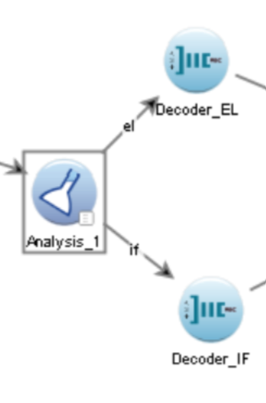

**Decoder Agents ( Analysis_1 Decoder_EL , Analysis_1 Decoder_IF )**

* 1. **Decoder_EL:**

Based on the decoder object of Dec_EqLease in the ultra file, it has 3 split ups of the data one based on:

* 1. **Header:** Categories the record as a header if the records outletid starts with “HDR” eg: “HDR2345”

external EquipHeader : identified_by(strStartsWith(outletId, "HDR")) {

};

* 1. **Trailer:** Categories the record as a trailer if the record’s outletid starts with “TRL”.

external EquipTrailer : identified_by(strStartsWith(outletId, "TRL")) {

};

* 1. **Body:** Record is considered an EquipRequest record if is follows these criteria’s

such as:

external EquipRequest : identified_by

(!strStartsWith(outletId, "HDR") &&

!strStartsWith(outletId, "TRL") &&

( ( documentType == "IE" && priceType == null ) ||

( documentType == "UL" && lineType == "RS" && priceType == null ) ||

( documentType == "AM" && lineType == "RS" && priceType == null ) ||

(strLength(priceType) == 3 ) ) ), terminated_by(0xA) {};

**3.2) Decoder_IF:**

Based on the decoder object of Dec_IF_EqLease in the ultra file, it has 3 split ups of the data one based on:

1. **Header:** *Same as that of Decoder_EL*
2. **Trailer:** *Same as that of Decoder_EL*
3. **Body:** Based on the records removalIndicator if they are “L0” and “UL”

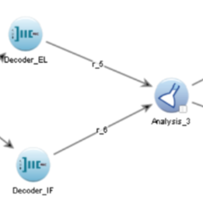

**Analysis Agent ( Decoder_EL Analysis_3 , Decoder_IF Analysis_3 )**

1. **Analysis_3:**

*Expected Input: EquipRequest, EquipHeader, EquipTrailer, IF_EquipRequest*

*Expected Output: Is same as that of Input.*

This workflow is responsible for keep track of the records and its corresponding changes taking place throughout the various timestamps(aka files generated at said timestamp).

We have an additional logic for headers for the records , i.e if the headers are recurring then we only send 1 header (this is for both EL and IF file)

And finally , only route those records that are not processed.

We keep track of the records and its changes taking place with the use of maps.

*map<string, EquipRequest> MAP_BP_NUMBER;*

*map<string, IF_EquipRequest> MAP_BP_NUMBERTWO;*

***Initialize Block:***

1. *We create the maps before the processing of the records begin.*

***Consume Block:***

1. *We first check on what record whether it’s a header , or whether it’s a trailer or an EL or IF file record.*
2. *For the EL and IF file records:*
3. *We create a unique key for said record for the map.*
4. *If said record is not present in the map and Not Processed then we store it into the list.*
5. *If record is present in the map for the key*

*3.1) If the record is processed -> We remove the record as the recon report should only consist of Not Processed Records, as the record is now no longer having any issues with it.*

*3.2) If the record is not processed still -> We then update the record with the latest comment , as the problem which appeared earlier may not be the same at a later timestamp.*

***Drain Block:***

*We are using the drain block as drain block will only execute at the end of the file, so at that stage the map would have collected all the records that are not Processed.*

1. *We first route the header out 1 time, only if map has got records present in it.*
2. *We then traverse the map and sent the records over to the Encoders.*

*MAP_BP_NUMBER -> Consists of only EL records and its records are routed to*

*Encoder_1 in drain*

*MAP_BP_NUMBERTWO -> Consists of only IF records and its records are routed to*

*Encoder_2 in drain*

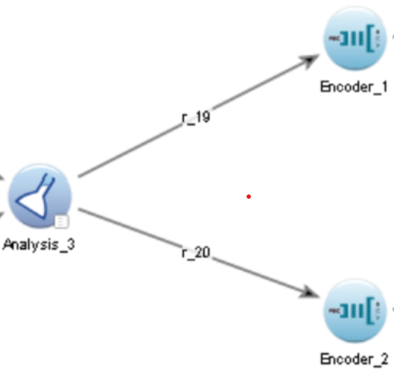

**Encoder Agents ( Analysis_3 Encoder_1 , Analysis_3 Encoder_2 )**

1. **Encoder_1:** Based on the Enc_EqpLease encoder object in ultra responsible for conversion of header , trailer and body back to external after processing is done
2. **Encoder_2:** Based on Enc_IF_EqpLease encoder object in ultra responsible for conversion IF records Header,Trailer and Body back to external format.

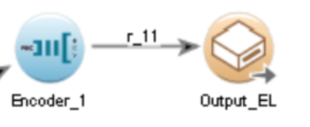

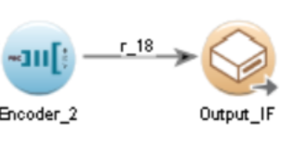

**Forwarding Agents( Encoder_1 Output_EL , Encoder_2 Output_IF )**

1. **Output_EL(Disk Forwarding Agent):** This agent collects all EL records from the Analysis Agent and stores in the given output file path.

The filename of the output file will be user defined and will include the timestamp of the merge agent.

Eg: *Recon_EL_202409111215.csv*

*Ouput file path: RECON_OUTPUT: /usr/sap/interfaces/MZD/LeaseBilling/Recon/output*

1. **Output_IF(Disk Forwarding Agent):** This agent collects all IF records from the Analysis Agent and stores in the given output file path.

The filename of the output file will be user defined and will include the timestamp of the merge agent

Eg. Recon_IF_202409111215.csv

*Ouput file path: RECON_OUTPUT: /usr/sap/interfaces/MZD/LeaseBilling/Recon/output*

***WFL_Recon_MailScript***

This script picks up the EL & IF files AND a file from SOM for today from *RECON_OUTPUT* and send to required business users.